Assignment 2

Name: Suryansh Sandeep Kumar Singh

Div.: B

Roll No: S1951122

PRN: 72018560C

Problem Statement: -

Code:

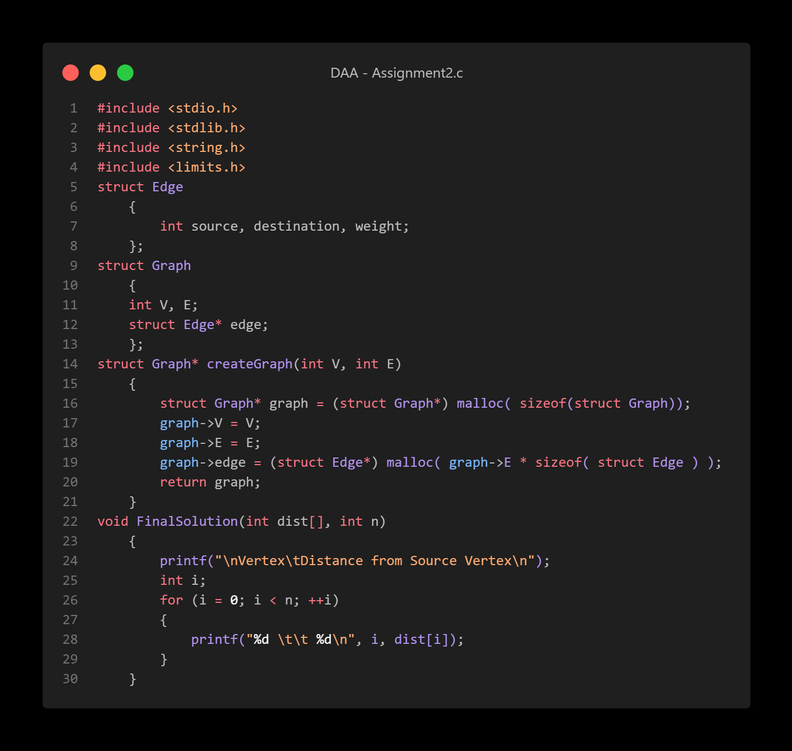

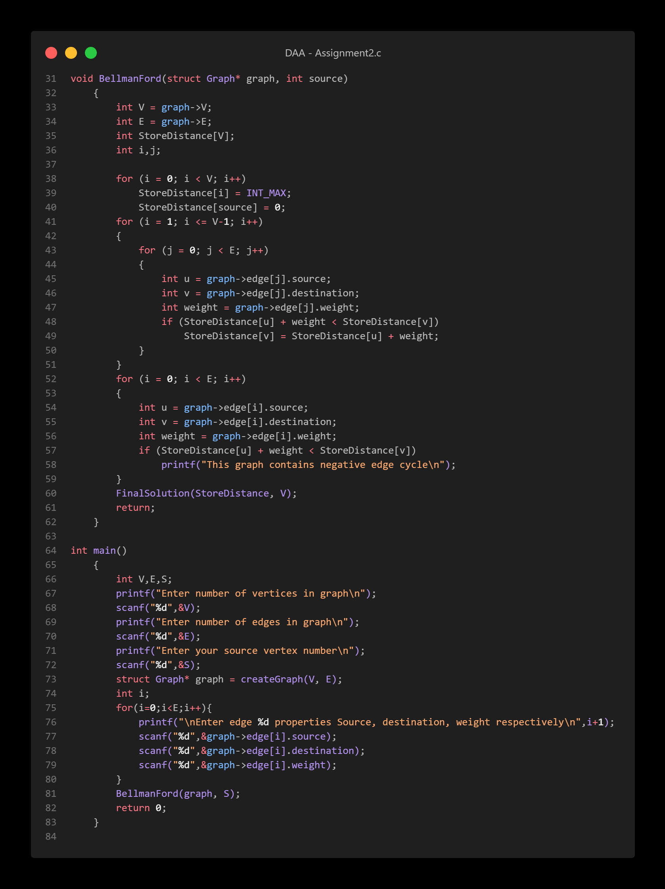

Output:

